Installing new HSR82 (4K) board in the SP3, SDP-45 and MC-14

This document applies only to SP3, SDP-45 and MC-14 units equipped with the board set rev 4.0 or later. For older board sets, see ADDENDUM.

To get to the board, you need to open the top cover using Torx #8 screwdriver . If the screws are very tight and hard to unscrew, apply a small amount of oil (for example WD40, machine oil, engine oil etc ), put a screwdriver vertically, at right angle onto each of the screw and tap lightly on the scredriver with a hammer in order to loosen the screw. Then gently loosen the screw.

An alternative method (by Rob Bowler, from Bryston production) to loosen the screws while avoiding stripping screws while trying to get the top off the SP3 unit:
- attempt to turn screw clockwise about a quarter turn or less, using a hand torx #8 screwdriver (do not
use a screwgun or any type of power driver, or the screwheads will have a greater chance of stripping), until you hear the screw make a slight "snap" sound. This indicates that the screw is breaking it's seal with the top. Now the screw can be turned counter-clockwise until it is out of the top. Repeat this step with all screws in the top to prevent screws from stripping.

To remove the HDMI board (HSR83D), use Torx #10 screwdriver , loosen the 8 screws marked in the Fig.1 below with yellow arrows.
( The four far screws are under a lip of the back panel so the screwdriver has to be at about ~20deg angle but a Torx screwdriver can easily handle such angle.)

Unscrew ten M3 screws holding the HDMI input/output tabs to the back panel, using Philips screwdriver.

Unplug the ribbon cables, take out the old HDMI board (HSR8-3D), put a new HSR82 board in its place and install the screws as above, in the reverse order. That is, first put the Philips M3 screw holding the input output tabs to the back panel, then install the 8 screws holding the board to the top panel.

SDP45 unit with an open top cover and the new board set (4.0) is shown on Fig.1 below.

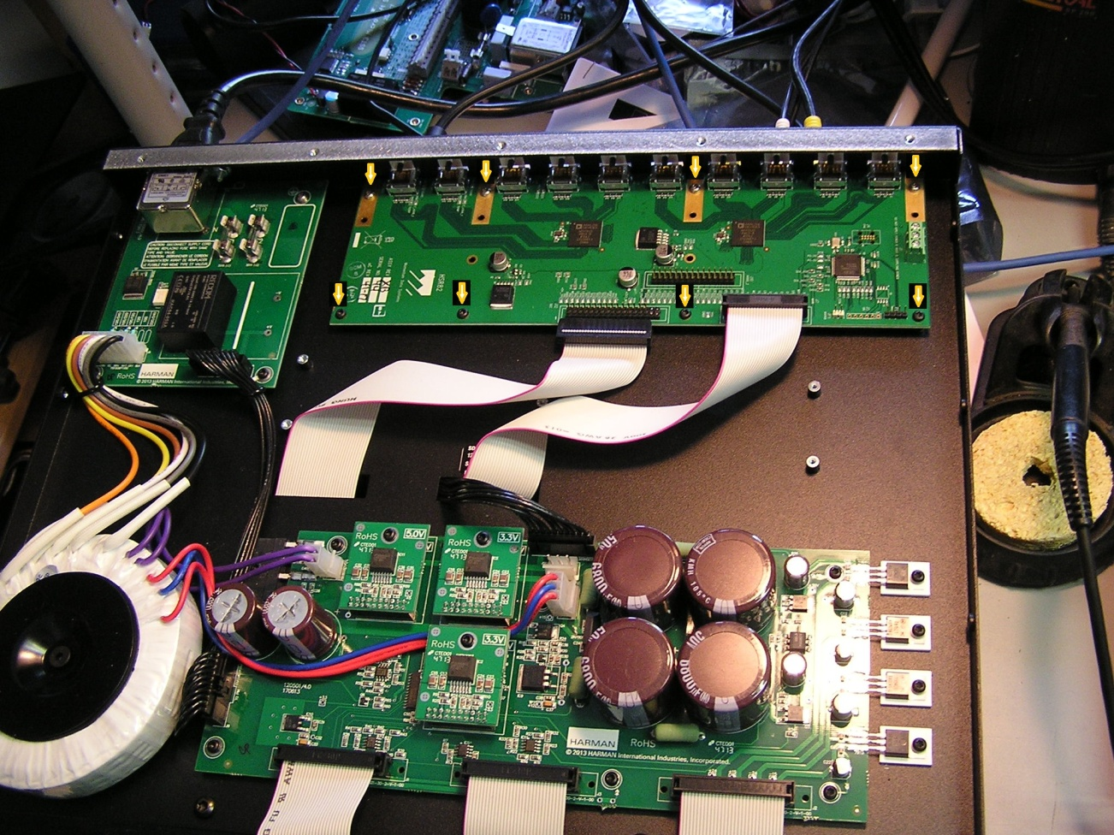

FIG.1. Revision 4.0 board set.

There are 2 ribbon cables:

1) 26-way cable plugs into 26-way header on the HSR82 board

2) 30-way ribbon cable plugs into a 34-way header J12 on the HSR82, with the header pins 31,32,33 and 34 cut off (see yellow arrow, Fig.2). If the HSR82 board arrived with the 34-way header with all 34 pins, cut the last 4 pins flush with the base of the header, with a small wire cutting tool, for example, like this:

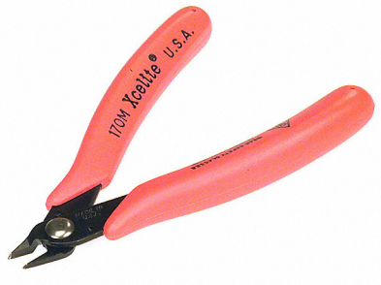
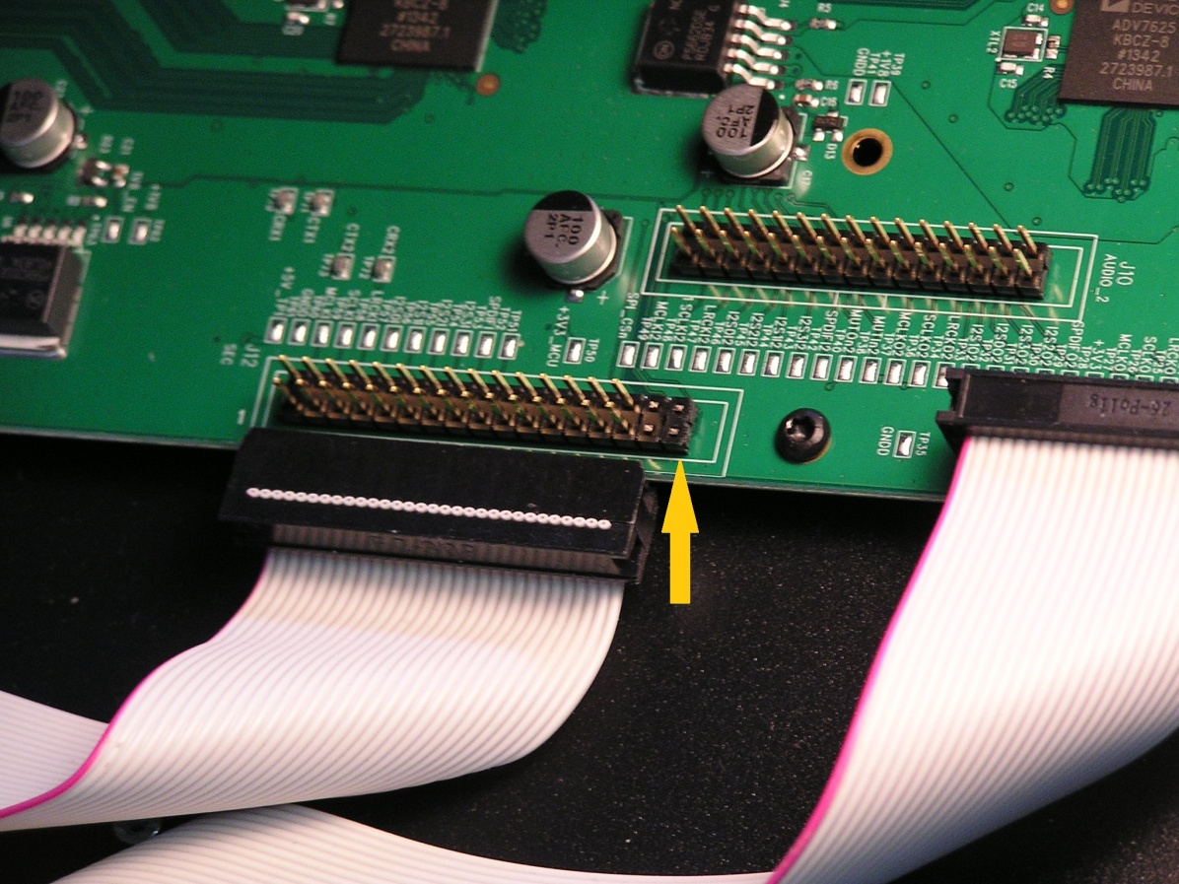

FIG.2

Once the new board is installed, close the top cover, put the Torx #8 screws back in (use manual - not power screwdriver, and do not over-tighten the screws!).

Finally, upgrade the firmware to revision 2014.06b or later.

It is recommended to re-default all user parameter after the firmware upgrade, by executing: SYSTEM SETUP-->MISCELANEOUS-->DEFAULT EEPROM

________________________________________

ADDENDUM

If the unit is equipped with an older board set, revision 3.0 or 2.0 then the HSR82 board would have to have two 220pF capacitors (size 0805, 6V or higher) added between SDA_HOST (TP14) and ground (TP16), and SCL_HOST (TP15) and ground (TP16), respectively, to suppress noise. See Fig.4 below. An older board set can be recognized by the presence of an intermediate junction board on the top panel, mounted between the HSR board and the power supply board, as seen on the Fig.3 (below).

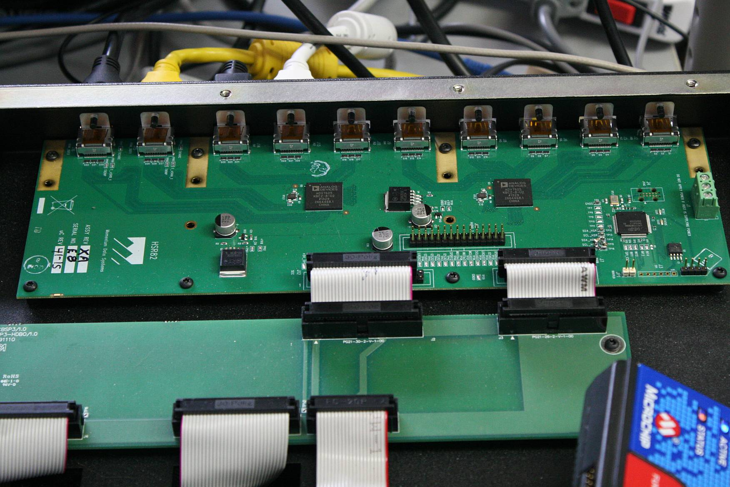
FIG.3 Top panel view, old board set.

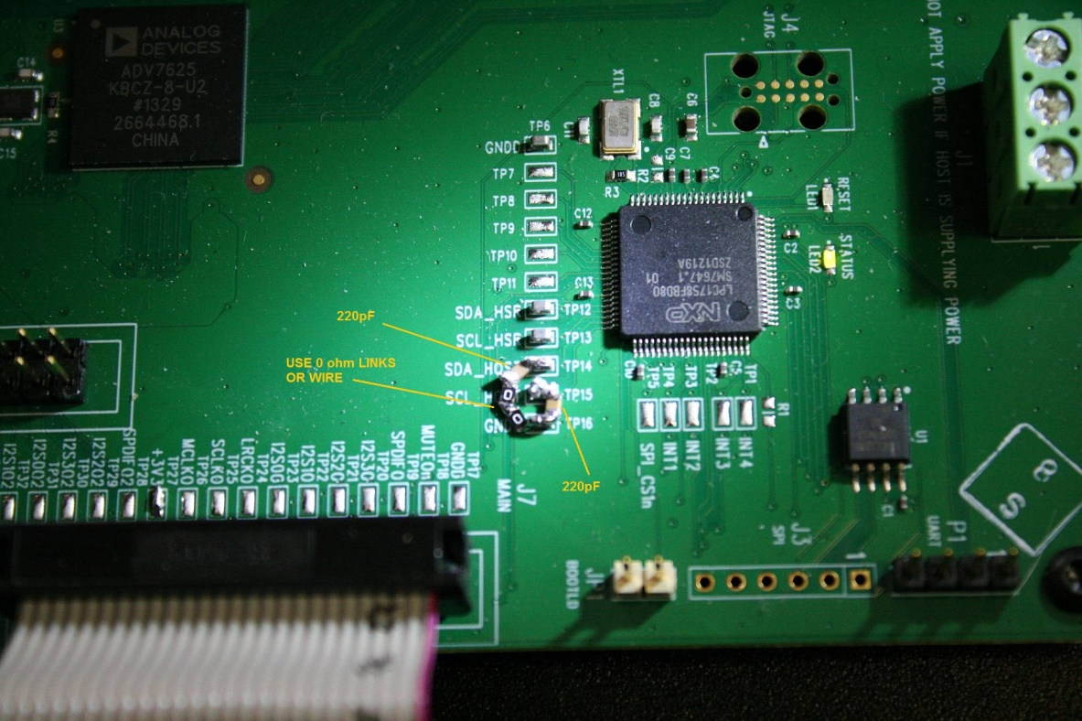
FIG.4 Two 220pF caps added to HSR82 board.

Draft.3 25-June-2014
(Stan Bleszynski, Bryston)

To recognize the new revision 4.0 SDP45 & MC14 boards set, notice the lack of a center distribution board for the two ribbon cables, that is the two ribbon cables come from underneath and plug directly into the HDMI board, as in the Fig.1. If a unit is equipped with the older board set, revision 3.0 or 2.0 then the HSR82 board would have to have two 220pF capacitors added between SDA_HOST (TP14) and ground (TP16), and SCL_HOST (TP15) and ground (TP16), respectively, to suppress noise.
http://www.digikey.ca/product-detail/en/36274/431-1137-ND/510977
Not vegetable oil!
http://www.digikey.ca/product-detail/en/36270/431-1182-ND/512242
The firmware can be installed before the board swap or without the board swap. It could be used with the old HDMI board since the release 2014.06b+ is compatible with both old and the new boards.

