Installing new USBX board in SP3,SDP-45,MC-14
Document rev.2, 25/04/2016 (Stan B., Bryston)

This document applies to SP3, SDP-45 and MC-14 units equipped with the board set rev 4.0 or later.

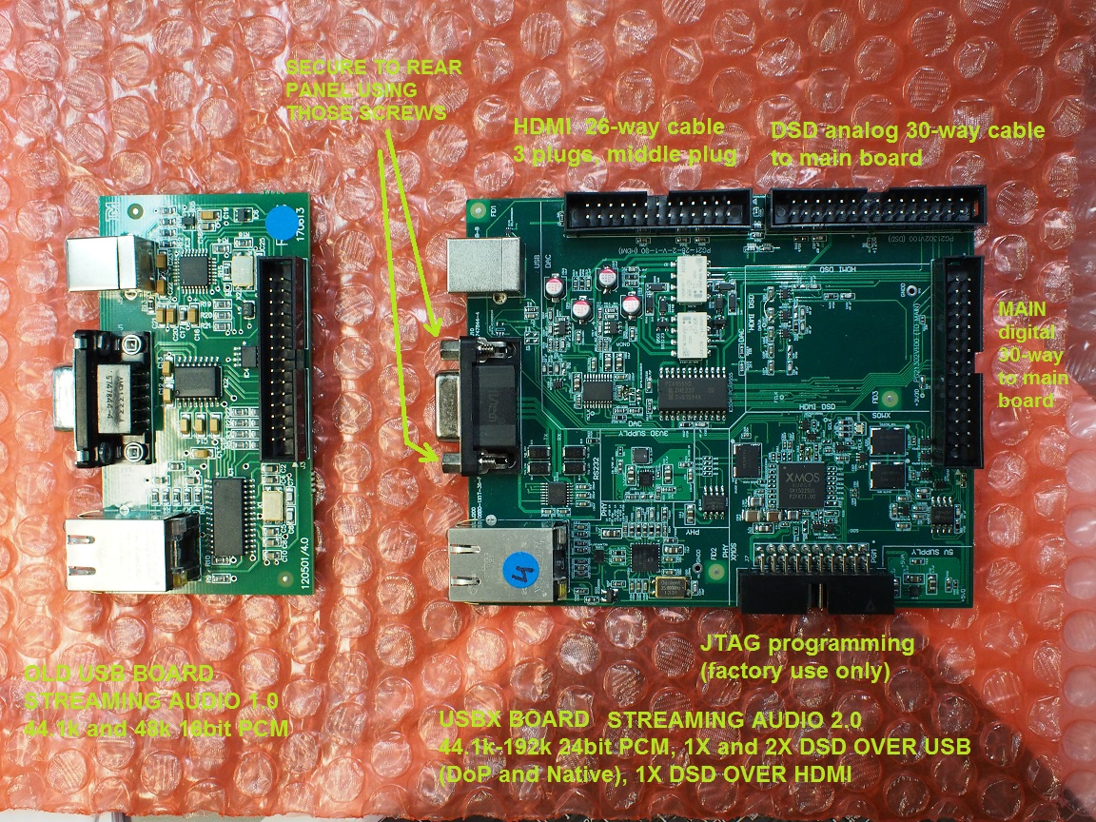

FIG.1. Old and new USB board

Installing Cables.

Note: installing of the 30-way DSD header J15 for the DSD analog cable, requires cutting tracks on the main board between J15 header pins 3 & 4 and pins 5 & 6, BEFORE THE HEADER IS SOLDERED!

There are 3 ribbon cables:

1) MAIN digital cable.
30-way ribbon cable between the USBX board (MAIN header) and the 30-way header on back of the main oard (the same that the old USB board was using). This cable caries the main I2S digital audio signals from the USB, control signals, Serial Bus for Ethernet and serial RS232 signals. This cable is not optional and must be present. The old MAIN cable is too short (7cm) to be re-used, a longer 13cm cable must be installed. which is available from Bryston stock #100087.

2) DSD Analog cable. This is optional cable allowing the playback of 2 channel DSD over USB and over HDMI. This cable allows also to enable phono-clipping feature on a menu-selectable analog input source.
30-way 32cm long ribbon cable (Bryston stock #100076) connects a 30-way straight dual-in-line pitch 0.1" pin header (digikey 609-3456-ND) soldered in J15 "DSD" header on the main board . Before the header is soldered, the tracks joining pins3 and 4, and pins 5 and 6 of the J15 header on the main board, must be cut as on the picture below.

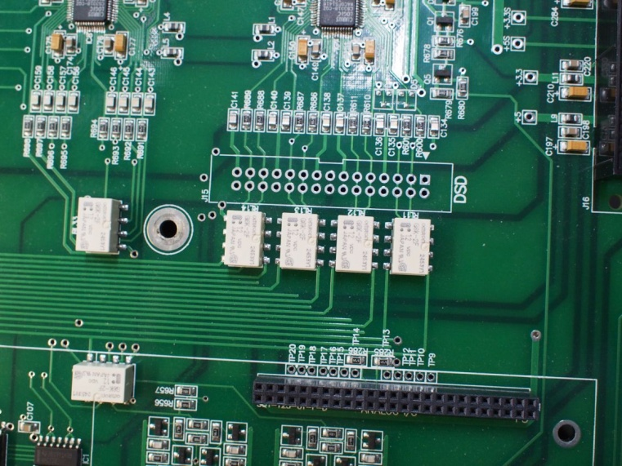
Fig. 2. J15 DSD header before traces are cut and before a pin-header is soldered in.

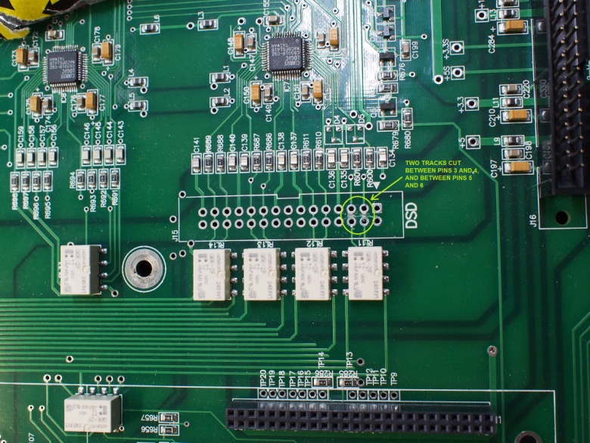

Fig.3a. J15 DSD header with traces cut.
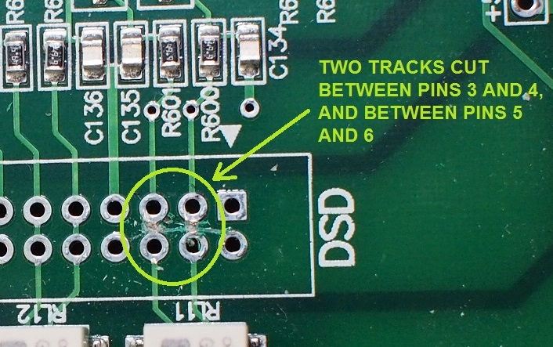

Fig.3b. J15 DSD header with traces cut.

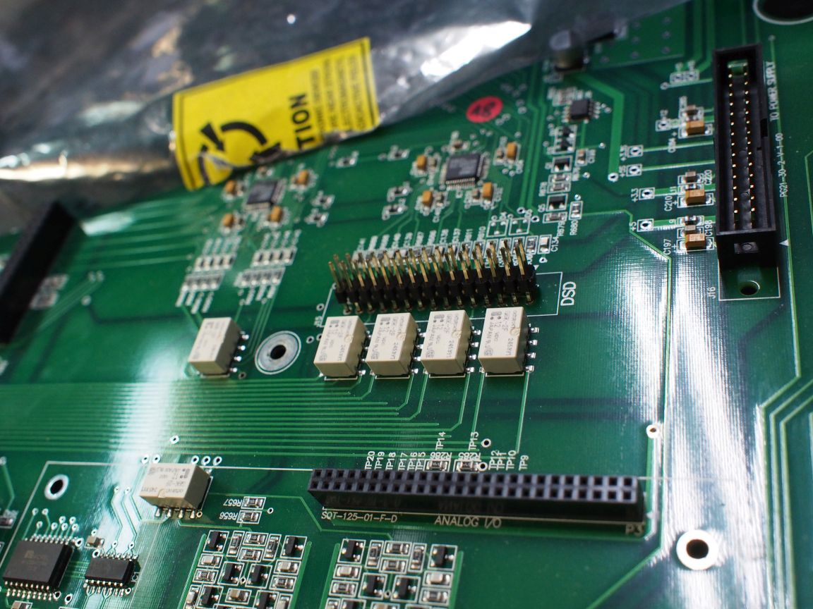

Fig.3c. J15 DSD header with pin header soldered.
Note: the pins of the 30-way through-hole header on J15, should normally be soldered from the back of the MAIN board, thus the main board should be completely dismounted from the chassis. Alternatively, it is more convenient (but not recommended) to solder the pin header from above (from the component side of the main board), without dismantling the board. It requires more soldering skills, a narrow-tipped soldering iron and a header with longer bottom pins so that a tip of the soldering iron can reach the header pads.

3) HDMI DSD cable. Optional cable allowing DSD over HDMI playback.
26-way HDMI cable 60cm long with 3 female plugs (the middle plug crimped at 21cm distance from one end) , comes from the main board, plugs into 26-way header and then goes to the HSR82 board. It is recommended to plug the middle socket of the cable on to the USBX board header before the board is attached to the back panel , otherwise it is harder to do. This cable is needed for intercepting DSD signals transmitted by the HDMI HSR82 board to the main board. If no DSD over HDMI is needed then this cable does not have to be installed.

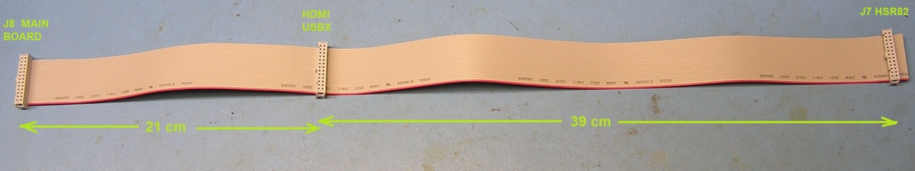

Fig.4

After the cables are plugged in, attach the USBX board to the rear panel using the 2 screw-posts (#4-40) at the DB9 connector (RS232).

FEATURE: | PCM 192k/24b (surround) | DSD over USB (stereo) | DSD over HDMI (stereo) | Phono Clipping
MAIN cable | + | + | + | +
DSD analog cable |  | + | + | +
HDMI DSD cable |  |  | +

Table 1. Availability of various features dependent on the cable set installation.

Installing a mounting post to secure the back of the USBX board.

This is important to prevent the board from rattling during transport, which may potentially damage the board or cause the cables to come loose off the headers.

If the USBX board has a mounting hole in a back back corner (production boards only), then install a 25-28mm long threaded (#4-40) post to secure the back of the board, using an existing pem post above it located on the upper chassis. Replace a short 0.25" #4-40 screw holding the power supply board onto this pem, from above, with a longer 0.75" screw so that it will extend down through it, and mount a #4-40 threaded post onto it. Then secure the USBX board to the post with a #4-40 nut.

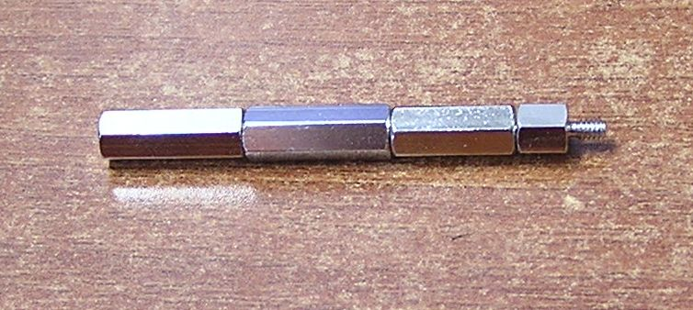
Fig.5. Mounting posts, threaded #4-40

Once the new board is installed, close the top cover, put the Torx #8 screws back in (use manual - not power screwdriver, and do not over-tighten the screws!).

Finally, upgrade the firmware to revision 2016.04b or later. This firmware will automatically recognise the new USBX board and will automatically detect which of the optional cables are connected. It is also back-compatible with the old USB board. There is no need to configure the new software.

________________________________________

(Stan Bleszynski, Bryston)

DSD over HDMI feature requires in addition the 26-way HDMI DSD cable to be installed
As long as DSD Analog cable is also installed!
order cable Digikey H1CXH-2636G-ND (Assman cable assy, 91cm long with 1 keyed socket) and 2 Assman 26-way crimped keyed sockets (per cable) AE11120-ND (or HKC26H-ND). Trim the cable length to 61cm and then crimp two extra sockets at 21cm distance and at 60cm distance from one end, such that the sable has 3 sockets crimped as on Fig.4.
SP3 firmware revision 2016.04b or higher will automatically recognize on power-up, a presence of each of the cables and the type of the USB old versus USBX board installation. No software setup is necessary.
Prototype boards no not have mounting holes)
The post can be combined using one 19mm post (Bryston stock part number 1946) and one 6mm post (Bryston stock part number 8713)

